Huevos Rancheros

* [Nutrition](http://www.beachbody.com/beachbodyblog/category/nutrition)

* [Recipes](http://www.beachbody.com/beachbodyblog/category/nutrition/recipes)

April 29, 2014

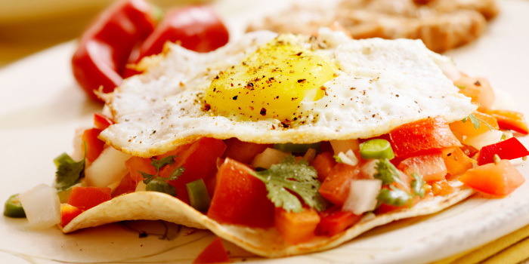

This Mexican egg dish makes a perfect weekend breakfast.

**Total Time:** 35 min.  
**Prep Time:** 10 min.  
**Cooking Time:** 25 min.  
**Yield:** 4 servings

**Ingredients:**  
2 tsp. olive oil  
1 medium onion, chopped  
1 (14.5-oz.) can diced tomatoes  
1 (4-oz.) can diced green chiles  
½ tsp. ground chili powder  
¼ tsp. sea salt  
Nonstick cooking spray  
4 large eggs  
4 corn tortillas, warm  
2 Tbsp. finely chopped red onion  
2 Tbsp. shredded Monterey jack cheese  
Cilantro leaves (for garnish; optional)

**Preparation:**  
1. Heat oil in medium nonstick skillet over medium-high heat.  
2. Add onion; cook, stirring frequently, for 4 to 5 minutes, or until onion is translucent.  
3. Add tomatoes and green chiles; cook, stirring occasionally, for 10 minutes.  
4. Season with chili powder and salt; cook, stirring frequently, for 5 minutes. Remove from heat. Set aside.  
5. Heat large nonstick skillet, lightly coated with spray, over medium heat.  
6. Add eggs one at a time, taking care egg whites don’t touch; cook, covered, for 3 minutes. Remove lid. Cook to desired yolk consistency. Remove from heat.  
7. Top each tortilla evenly with onion mixture. Top gently with egg and top evenly with red onion and cheese.  
8. Garnish with a cilantro leaf if desired.

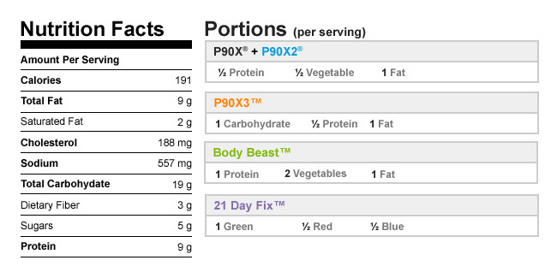

Authors

[Beachbody](http://www.beachbody.com/beachbodyblog/author/beachbody)

Tags[breakfast](http://www.beachbody.com/beachbodyblog/tag/breakfast), [cinco de mayo](http://www.beachbody.com/beachbodyblog/tag/cinco-de-mayo),[eggs](http://www.beachbody.com/beachbodyblog/tag/eggs), [high-protein](http://www.beachbody.com/beachbodyblog/tag/high-protein),[mexican](http://www.beachbody.com/beachbodyblog/tag/mexican), [recipes](http://www.beachbody.com/beachbodyblog/tag/recipe)

RELATED POSTS